Azure Practical No. 02
Organize and Protect Resources with Tags and Locks
1. Aim
To organize Azure resources using tags and protect them from accidental deletion by applying and testing resource locks.
2. Theory
Azure Resource Tags
- Tags are name-value pairs used to organize and identify Azure resources.
- They help in resource management, filtering, organization and cost tracking.
- A tag consists of a Name and a corresponding Value.
Azure Resource Locks
- Resource locks help prevent accidental modification or deletion of Azure resources.
- The two main lock types are Read-only and Delete.
- A Delete lock allows normal use of a resource but prevents its deletion until the lock is removed.
- Locks can be applied at resource, resource group or subscription scope.
3. Procedure / Main Tasks
Task 1 — Create resources and apply tags
- Sign in to the Azure portal using the provided lab environment.
- Create or open the required resource group and resources specified in the lab.
- Open the Tags section for the required resource.
- Add the required Name and Value tag pairs and save the changes.
- Verify that the tags are displayed on the resource.
Observation: Tags were added successfully and are displayed with the required resource information.
Screenshot Evidence
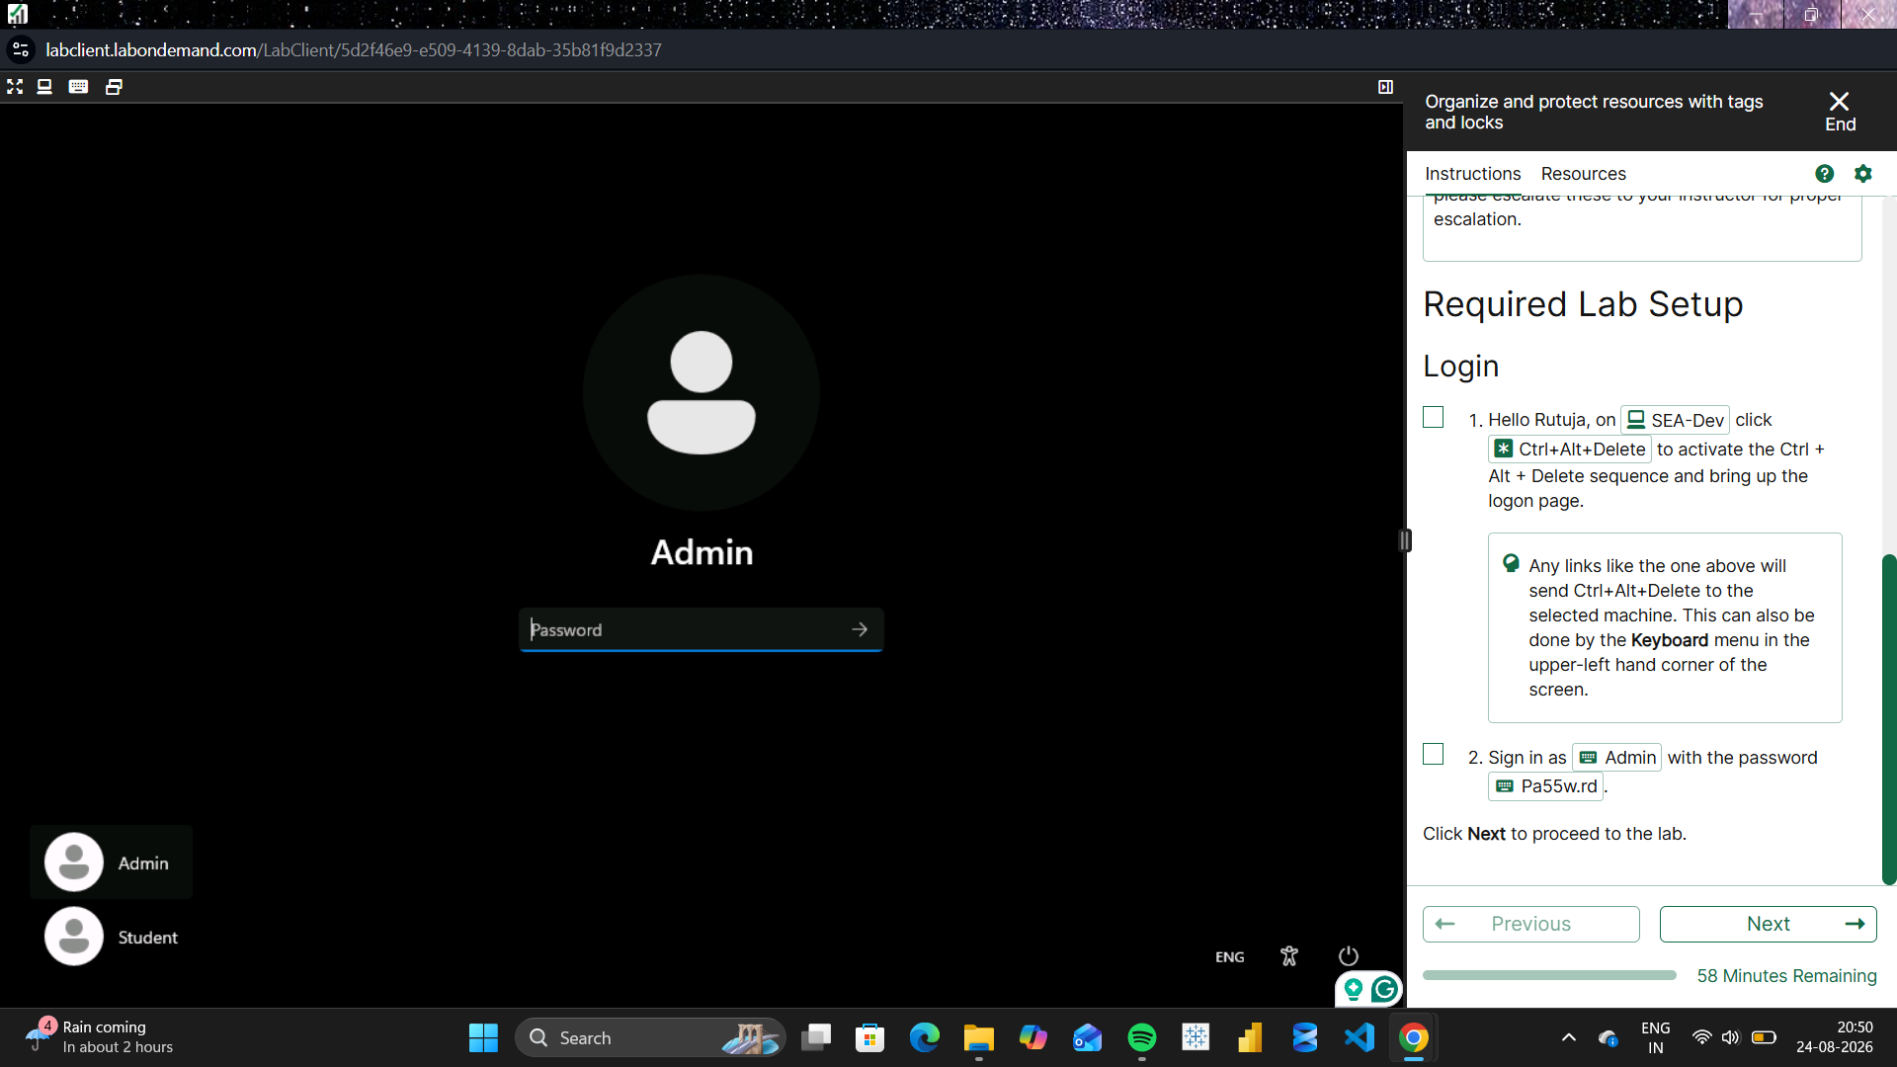
Screenshot 1
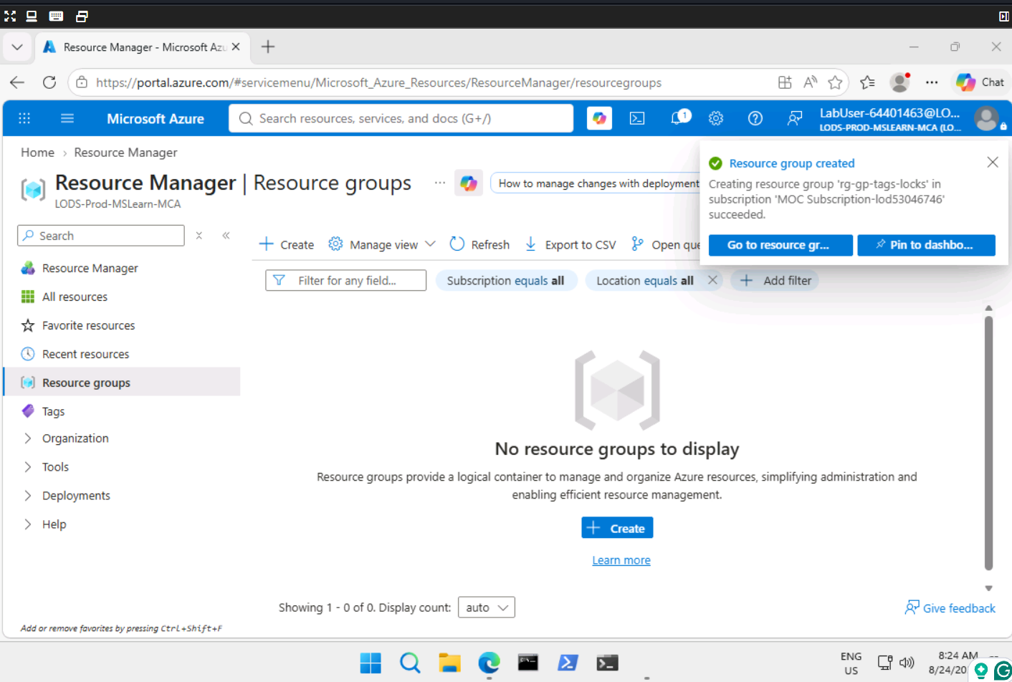
Screenshot 2
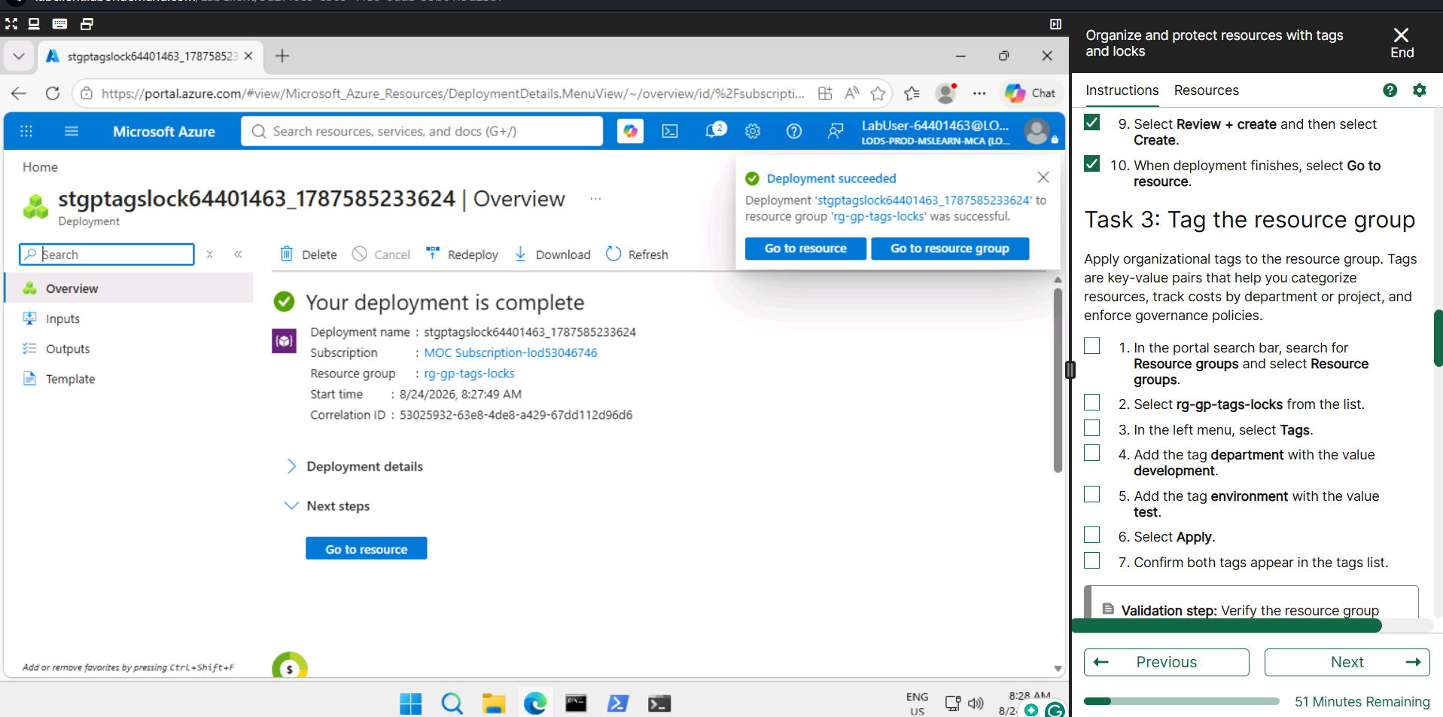
Screenshot 3
Task 2 — Apply resource locks
- Open the required Azure resource or resource group.
- Go to Settings → Locks.
- Select Add to create a resource lock.
- Enter the required lock name and select the Delete lock type.
- Create the lock and verify that it is listed for the resource.
Observation: A Delete lock was successfully applied to protect the resource from accidental deletion.
Screenshot Evidence
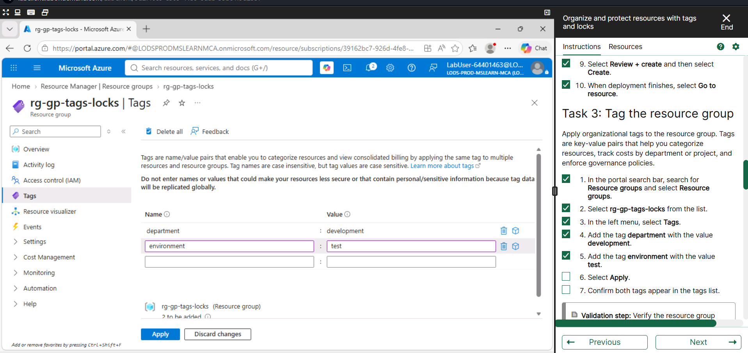
Screenshot 1
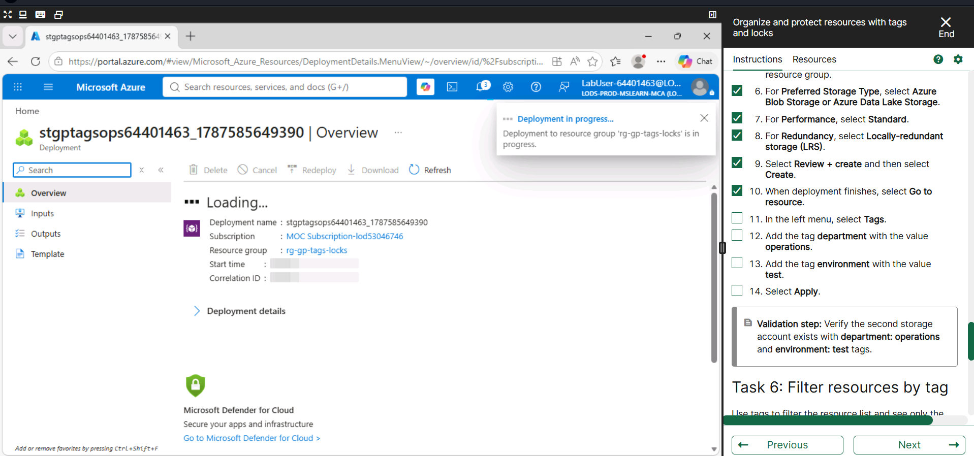
Screenshot 2
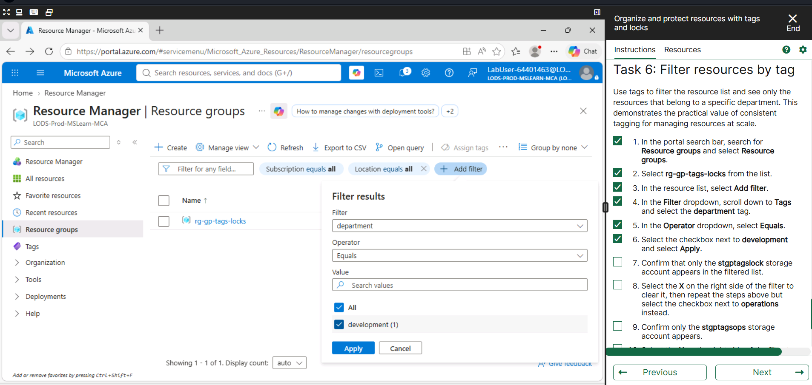
Screenshot 3
Task 3 — Test lock enforcement
- Select the protected resource or resource group and attempt to delete it.
- Verify that Azure prevents deletion because a Delete lock is applied.
- Return to Settings → Locks and remove the lock when instructed by the lab.
- Verify that the lock has been removed.
Observation: The Delete lock prevented deletion of the protected resource. The lock was removed as required.
Screenshot Evidence
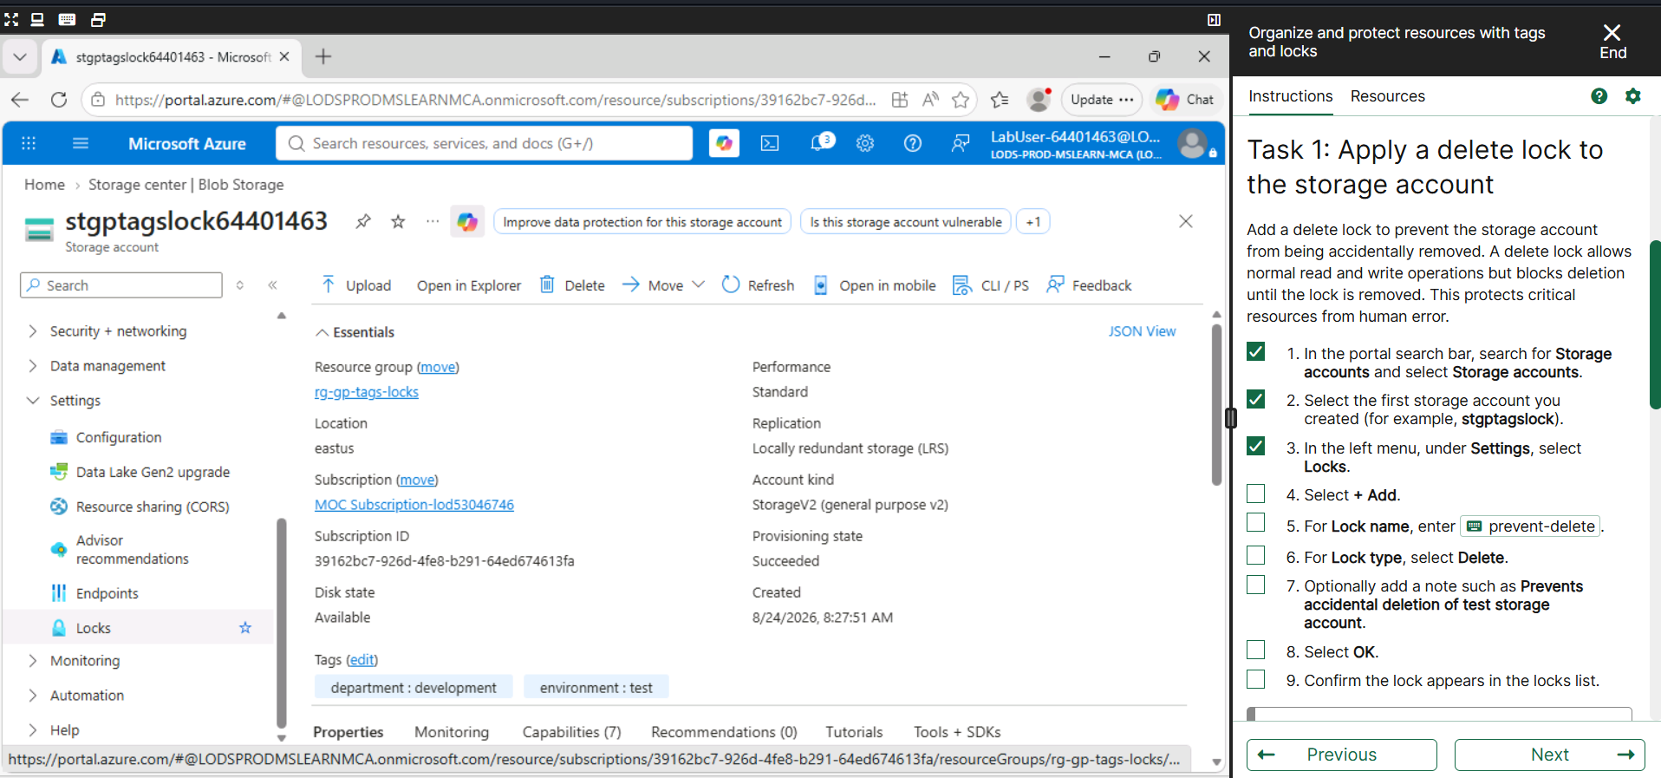
Screenshot 1
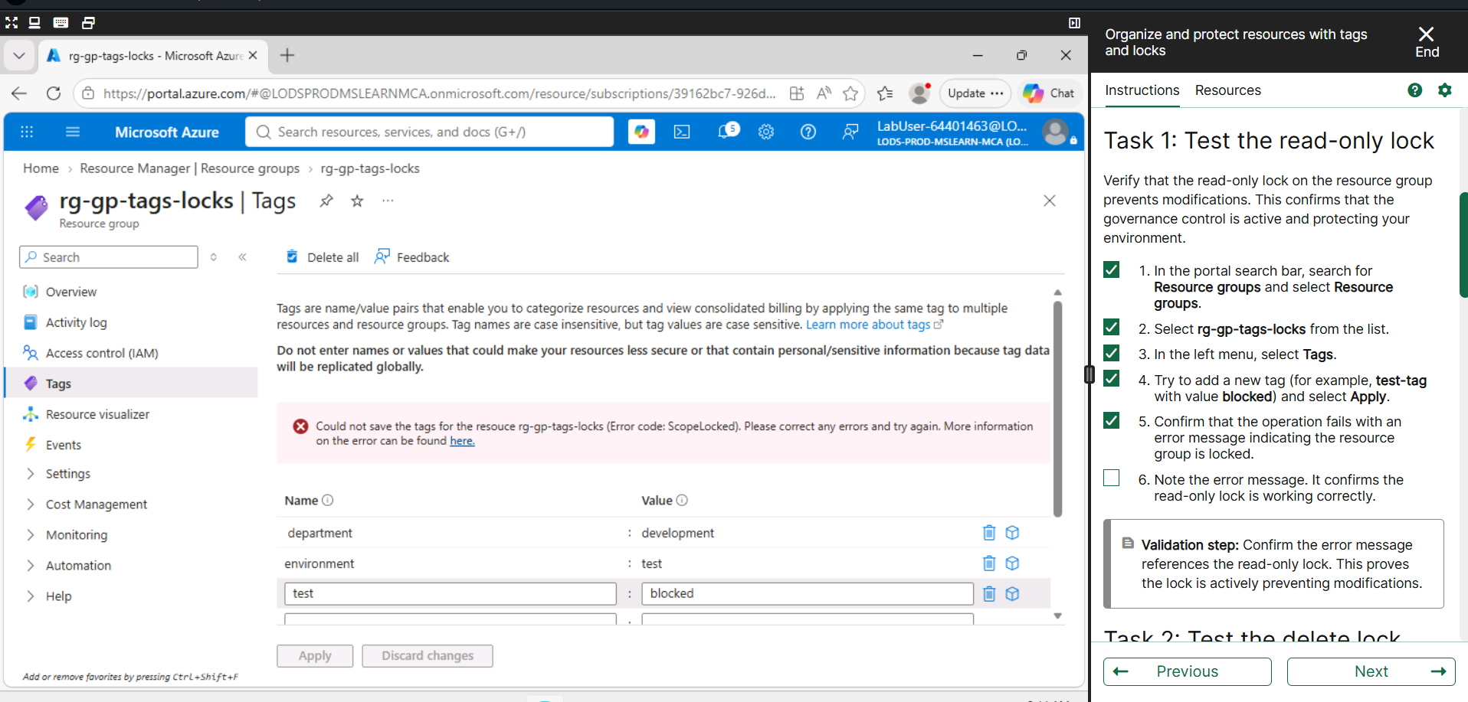
Screenshot 2
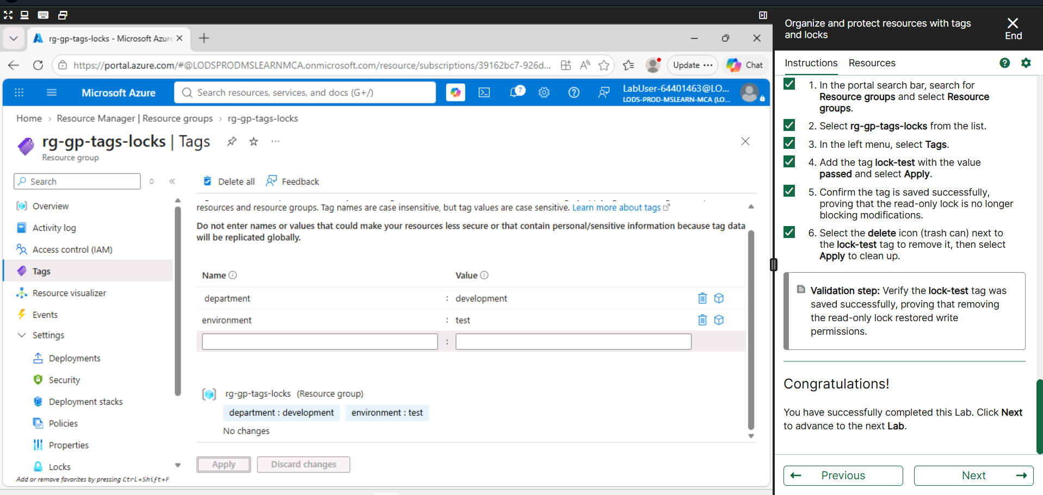
Screenshot 3
Task 4 — Validate success
- Verify that the required resources were created successfully.
- Verify that the required tags are present.
- Verify that the resource lock was created and tested successfully.
- Confirm the expected lab validation or success message.
Observation: The required resources, tags and lock configuration were successfully verified.
Screenshot Evidence
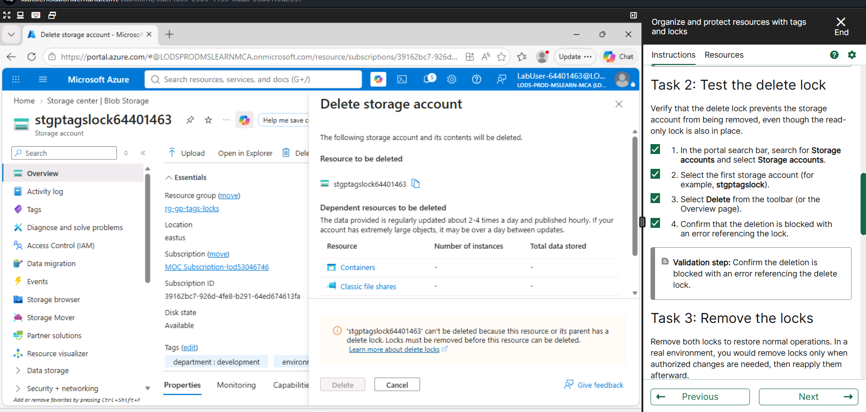
Screenshot 1
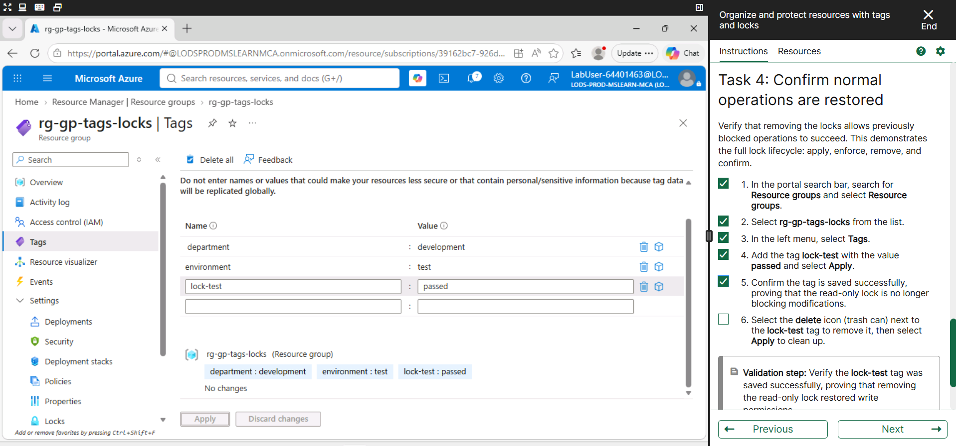
Screenshot 2
Task 5 — Clean up resources
- Remove the resource lock if it is still present and the lab requires deletion.
- Delete the resources created for the practical.
- Delete the resource group when instructed.
- Confirm that the resources have been removed.
Observation: The practical resources were cleaned up after completing the required activities.
Screenshot Evidence
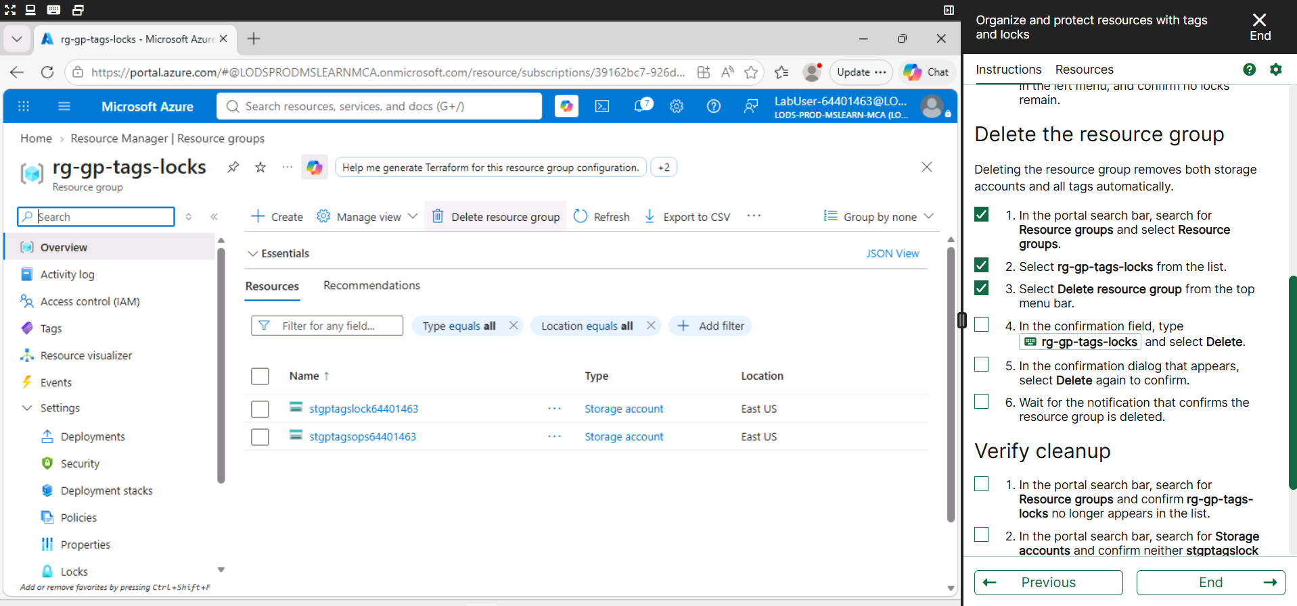
Screenshot 1
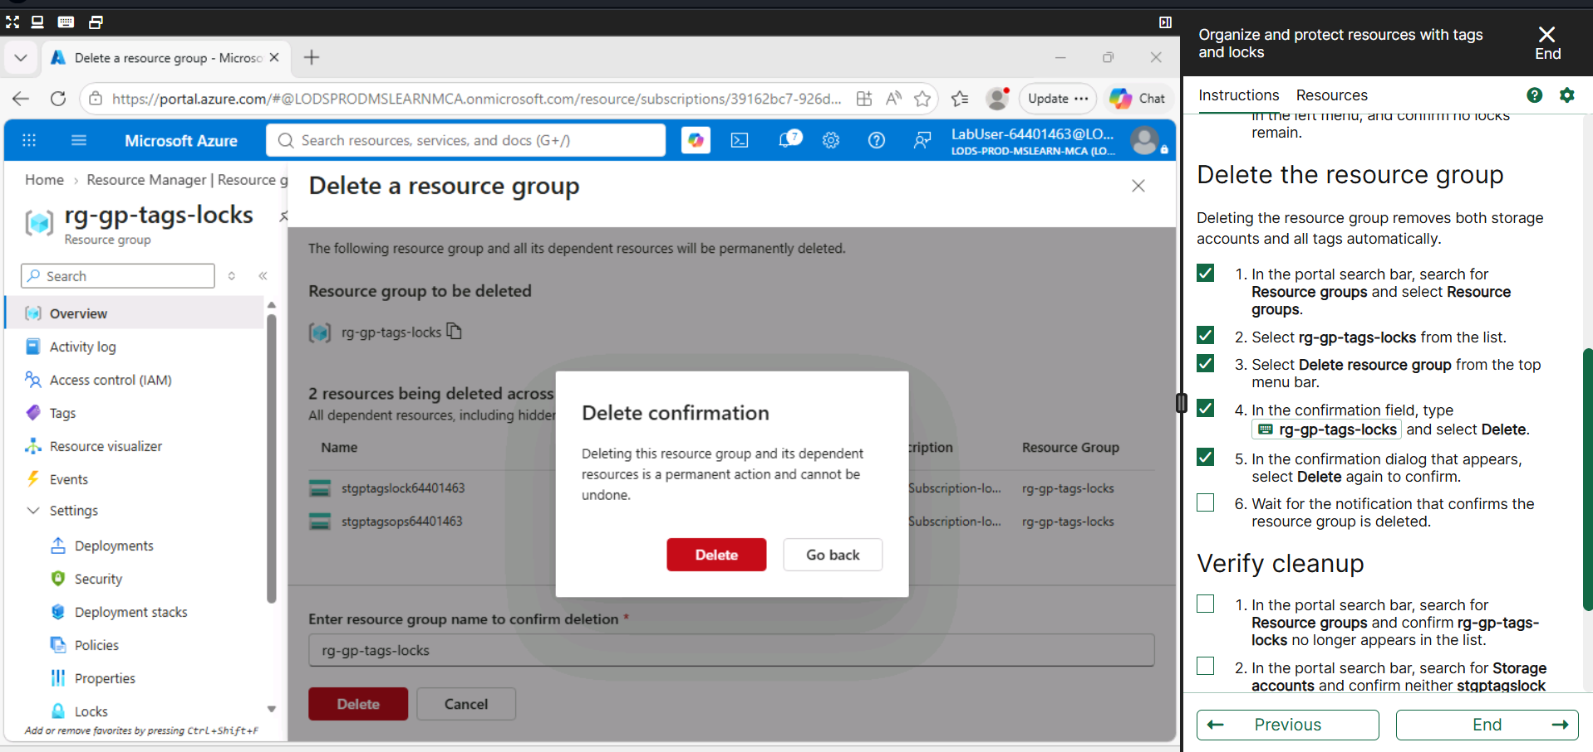
Screenshot 2
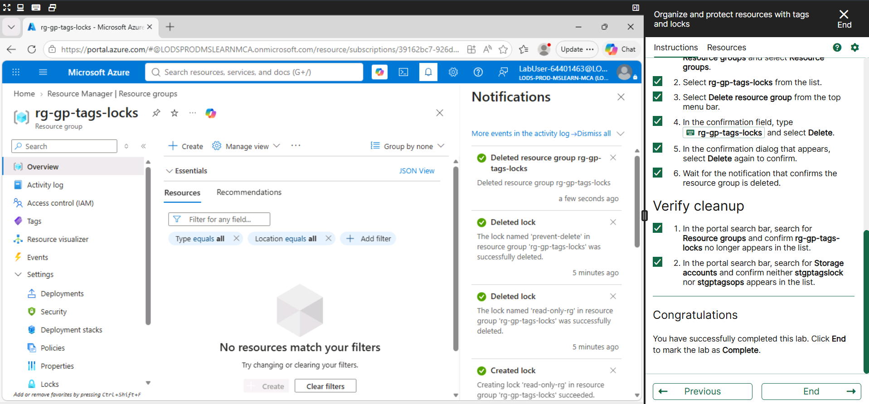
Screenshot 3
4. Result
Azure resources were successfully organized using tags and protected using a Delete lock. The lock enforcement was tested successfully, the lock was removed as required, and the resources were cleaned up.
5. Conclusion
Azure tags provide an effective method for organizing and tracking resources, while resource locks help protect resources from accidental deletion. Together, they improve Azure resource management and governance.

